P235/4
ISLAMIC
RELIGIOUS
EDUCATION
Paper 4
ISLAM IN AFRICA
DECEMBER, 2020
2½ hours

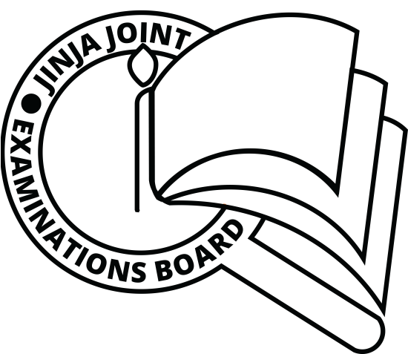

JINJA JOINT EXAMINATIONS BOARD

Uganda Advanced Certificate of Education

MOCK EXAMINATIONS – DECEMBER, 2020

ISLAMIC RELIGIOUS EDUCATION

ISLAM IN AFRICA

Paper 4

2 hours 30 minutes

INSTRUCTIONS TO CANDIDATES:

This question paper is divided into two sections, A and B.

Answer any FOUR questions; selecting at least one from each section

ALL questions carry equal marks.

SECTION A
1. “It was the good will of African chiefs that facilitated the spread of Islam in the interior Africa”. Discuss.
2. a) Examine the factors that led to the growth and development of
east African coastal markets.
b) How did the growth and development of the coastal markets
facilitate the spread of Islam along the coast of east Africa?
(b) How the local people cooperated with the Arabs.
3. How far has the Uganda Muslim Supreme Council (UMSC) benefited the Muslim community in Uganda since its inception in 1972?
4. (a) Discuss the socio-religious conditions on the East African coast
before the coming of Muslims.
(b) How did Islam address these conditions?
5. (a) Examine the relationship between Kenyan Muslims and the
Government.
(b) How have Muslims in Kenya benefited from this relationship?
6. Without Portuguese invasion, the ehole of East Africa would have been Islamized. Assess the validity of the assertion.

SECTION B (WEST AFRICA)
7. Explain the ways through which the Ancient kingdom of Ghana was
Islamized.

8 . Examine the strength and weaknesses of the Berbers to the spread of
Islamic culture in West Africa.
9. Discuss the contribution of Askia Muhammad in the development of
the Muslim community in Songhai Empire

10. Analyse the role of Tariq movement in the spread of Islam in west Africa.
11. Assess the role of sokoto jihad in the spread of Islam in west Africa.
12. Colonialism in Africa was absolutely negative to Islamic cause. How far true is the statement in West Africa?

